System Requirements Statement (SRS) –

e-Shiksha: Available for your dreams

1. Introduction……………………………………………..3
2. Functional Requirements…………………………….....4
   1. Student and Parent Module……………………………...6
   2. Teacher Module…………………………………………12
   3. Clerk Module……………………………………………22
   4. Admin Module………………………………………….28
   5. Use case Diagram……………………………………….33

# **Introduction**

This document explains the system requirements and scope for developing e-Shiksha System. e- Shiksha System could divide the four main parts, Student and parent part, Teacher part, Clerk part and Admin part. This document describes the system requirement of the Account part.

1. **Functional Requirements**

The Account part of e-Shiksha System has three modules which are divided 17 processes described as below:

|  |  |  |
| --- | --- | --- |
| **No** | **BRS requirement ID** | **Description** |
| **2.1** | **Student and Parent Module** | |
| **2.1.1** | **F1** | **Account Creation Process** |
| **2.1.2** | **F2** | **Login Process** |
| **2.1.3** | **F3** | **Forgot Password Process** |
| **2.1.4** | **F4** | **Change Password Process** |
| **2.1.5** | **F5** | **View Profile Process** |
| **2.1.6** | **F6** | **View Attendance** |
| **2.1.7** | **F7** | **View Timetable** |
| **2.1.8** | **F8** | **View Marks** |
| **2.1.9** | **F9** | **View Fee Details** |
| **2.1.10** | **F10** | **View Classmates and teachers** |
| **2.2** | **Teacher Module** | |
| **2.2.1** | **F11** | **Account Creation Process** |
| **2.2.2** | **F12** | **Login Process** |
| **2.2.3** | **F13** | **Forgot Password Process** |
| **2.2.4** | **F14** | **Change Password Process** |
| **2.2.5** | **F15** | **Update Account Process** |
| **2.2.6** | **F16** | **Update Student’s Account** |
| **2.2.7** | **F17** | **Update Parent’s Account** |
| **2.2.8** | **F18** | **Update Student’s Attendance** |
| **2.2.9** | **F19** | **Update Student’s Marks** |
| **2.2.10** | **F20** | **View Student List** |
| **2.2.11** | **F21** | **View Timetable** |
| **2.3 Clerk Module** | | |
| **2.3.1** | **F21** | **Account Creation Process** |
| **2.3.2** | **F22** | **Login Process** |
| **2.3.3** | **F23** | **Forgot Password Process** |
| **2.3.4** | **F24** | **Change Password Process** |
| **2.3.5** | **F25** | **Create Timetable** |
| **2.3.6** | **F26** | **Update Fee Details** |
| **2.4 Admin Module** | | |
| **2.4.1** | **F27** | **Login Process** |
| **2.4.2** | **F28** | **Forgot Password Process** |
| **2.4.3** | **F29** | **Change Password Process** |
| **2.4.4** | **F30** | **Update Account Process** |
| **2.4.5** | **F31** | **Report Generation** |
| **2.4.6** | **F32** | **Account Management** |

* 1. **Student and Parent module**
* Student and parent are the users who wants to see their attendance, timetable, marks, fee, profile and list of teachers and students.
  + 1. **Account Creation process**
* This is primary step of this system before login. e-Shiksha should provide function which makes student or parent to register to account before login.
* The registration process is common for student as well as parent.
* Parent can map child’s progress with marks, attendance.
* When student and parent create new account, function demands following information:

1. Login Information
2. Contact Details

* Login Information

Login Information consist of following:

1.User ID

2.Password

3. Email ID

4. First name

5.Last name

6.User type

All items are compulsory demanded.

* User ID:
* The User ID should be unique. If the User ID correspond with not case-sensitive to other which is previously registered, the User ID should not be registered as an account.
* Password:
* The Password has constrained which makes the Password consists of more than or equal 8 and less than or equal 16 characteristics including characters described as below.

1. Numeric figure (at least one)
2. Capital alphabet (A-Z) (at least one)
3. Small alphabet (a-z) (at least one)
4. Special character (#, $, %, &, etc.) (at least one)

* The Password is masked by dummy characters. The re-entering Password is demanded.
* The Password must be encrypted in e-Shiksha System.
* User type:

The user type consists of following categories:

1. Student or parent
2. Teacher
3. Clerk
4. Administrator

* User type can be “Student or parent”, “teacher”, “Clerk” and

“Administrator”.

* User can select student or parent
* No one could select Administrator because it is implemented to e-Shiksha system in advance.

` All items are mandatory.

* Contact Details

The Contact Detail consists of some items described as below.

1. Permanent Address
2. Contact No

* All items are compulsory demanded.
* Permanent Address
* Permanent Address should be filled.
* But only the state should be selected from options.
* The Security Question information

The Security Question information is needed when Student or parent lost their Password. This information consists of two items described as below.

1. Selected Question
2. Answer
   * All items are compulsory demanded.
   * Some questions which are difficult to answer for anyone else are prepared in advance.

E.g. which color do you like most?

* + A question should be selected from options by the teacher, and the Answer is registered by the teacher.
* Login information should be entered on one screen, and then teacher information and Security Question information should be entered on another screen.
  + 1. **Login Process**
* e-Shiksha System always compels user authentication before using itself except when a new account is successfully created.
* The user authentication demands User ID and Password. The user ID should be checked in following ways:
  + - First, The User ID and the Password should be existed and correct.
    - If the User ID and the Password are not equal to what the user has registered, the user authentication cannot be provided.
    - Second, the User Type linked to the User ID should be "Student or parent". When the User Type is "student or parent", then user can be placed on “student or parent Home”.
* Finally, User ID should be available.
* The Administrator can decide whether the User ID is available or suspended – Refer to the SRS of the Admin part.
* If student or parent is rejected, user authentication is not provided for system user.
* The student/parent account should alive for so long as the duration decided by Admin.
* Only when these checks are successfully completed, user can be placed on respected page.

The student home provides following items:

1. A trigger to logout
2. A trigger to Change Password
3. A trigger to view Profile
4. A Trigger to view attendance
5. A trigger to view timetable
6. A trigger to view marks
7. A Trigger to view Fee details
8. A trigger to view list of classmates and teachers
   * 1. **Forgot Password Process**

* When system user lost their Password, the recovery method should be provided by e-Shiksha system.

The recovery method is described as below.

* + First, system user enters their User ID for e-Shiksha System.
  + Next, e- Shiksha System demands the Answer which has been registered since when the Account was created.
  + Only when the Answer is correct, student/parent get the new password by E-mail which also has been registered since when the Account was created.
  + The new password is automatically generated by e- Shiksha System.
* Of course, the new password should consist of more than or equal 8 and less than or equal 16 characteristics including at least a numeric figure, a capital alphabet, a small alphabet, and a special character.
* As a consequence, The Student or parent could get the student or parent authentication using the new password.
  + Then, the student or parent had better change the new password manually.
* If the Answer is not correct, otherwise, the correct Answer is demanded for user again.
  + In that case, Of course, student or parent couldn’t get the new password.
    1. **Change Password Process**
* When student or parent wants to change their Password, the measure should be provided by e-Shiksha System.
* Therefore, e-Shiksha System should provide the function which is available after getting the student or parent authentication.
* The function demands for current password and new password.
* Of course, characters ranging between 8 to 16, should have at least one small case letter, one capital case letter and one special character.
* The current password and the new password are masked by using dummy characters.
* The new password is demanded to enter twice to avoid a typing error.
* Only when the current password is correct, student or parent could change their Password.
* When the current password is changed into new password, e-Shiksha System compels user authentication again.
  + 1. **View Profile Process**
* e-Shiksha System should provide the function which makes the account viewed for student or parent.
* The information student or parent could view is described below.

1. Login information
2. Contact Information

* The Log In information

The updatable items as described below.

1. User ID
2. E-mail address
3. First name
4. Last name

* Contact Information

The updatable items as described below:

* + - 1. Contact number
      2. Address details
    1. **View** **Attendance**

The student and parent could see information about attendance by selecting following methods:

* Daily
* Weekly
* Monthly
  + 1. **View Timetable**
* Student and parent can view timetable made for student.
  + 1. **View Marks**

**Search conditions are described below to view the marks:**

* Exam number
* Subject

**2.1.8 View fee details**

Student and parent could see the information about fee.

* + 1. **View classmates and teachers**

Student could see the information about his classmates and teachers.

Select conditions are described as below:

1. Classmates

2. Teachers

## 2.2 Teacher Module

* Teacher is the user of system who keeps track of student’s activity.
* Teacher can manage timetable, attendance, marks of student, manage profiles.

### 2.2.1 Account Creation Process

* e-Shiksha System compels to create the account before using it. So, e-Shiksha System should provide the function which makes teacher creates new account.
* When teacher creates new account, the function demands two information described as below.

1. Login information
2. Contact Details

* The Login information

The Login information consists of some items described as below.

1. User ID
2. Password
3. First Name
4. Last Name
5. E-mail address
6. User Type
   * All items are compulsory demanded.
   * User ID

* The User ID should be unique. If the User ID correspond with not case-sensitive to other which is previously registered, the User ID should not be registered as an account.
  + Password
* The Password has constraints which makes the Password consists of more than or equal 8 and less than or equal 16 characteristics including characters described as below.

1. Numeric figure (at least one)
2. Capital alphabet (A-Z) (at least one)
3. Small alphabet (a-z) (at least one)
4. Special character (#, $, %, &, etc.) (at least one)

* The Password is masked by dummy characters. The re-entering Password is demanded.
* The Password must be encrypted in e-Shiksha System.
  + User Type

The User Type falls into four categories described as below.

1. Teacher
2. Student/Parent
3. Clerk
4. Administrator

* The User Type defines also four types of user; "Teacher user", "Student/Parent user", “Clerk user” and "Administrator user”.
* In an Account Creation Process, the user can select Teacher.
* No one could select The Administrator, because Administrator is implemented to e-Shiksha System in advance.
* Contact Details
* The Contact Detail consists of some items described as below.
  + - 1. Permanent Address
      2. Contact No
  + All items are compulsory demanded.
  + Permanent Address
* Permanent Address should be filled.
* But only the state should be selected from options.
* The Security Question information

The Security Question information is needed when Teacher lost their Password. This information consists of two items described as below.

* + - 1. Selected Question
      2. Answer
  + All items are compulsory demanded.
  + Some questions which are difficult to answer for anyone else are prepared in advance.

E.g. which color do you like most?

* + A question should be selected from options by the teacher, and the Answer is registered by the teacher.
* Login information should be entered on one screen, and then teacher information and Security Question information should be entered on another screen.

### 2.2.2 Login Process

* e-Shiksha System always compels user authentication before using itself except when a new account is successfully created.
* The user authentication demands User ID and Password. The User ID and the Password should be checked in three ways.
  + First, The User ID and the Password should be existed and correct.
* If the User ID and the Password are not equal to what the user has registered, the user authentication cannot be provided.
  + Second, the User Type linked to the User ID should be "teacher".
* When the User Type is "teacher", then user can be placed on “teacher Home”.
  + Finally, User ID should be available.
* The Administrator can decide whether the User ID is available or suspended – Refer to the SRS of the Admin part.
* If teacher is rejected, user authentication is not provided for system user.
* The teacher account should alive for so long as the duration decided by Admin.
* Only when the three checks are successfully completed, teacher can be placed on respected page.
* The “teacher Home” provides some items described as below.

1. A trigger to logout
2. A trigger to update Profile
3. A trigger to Change Password
4. A trigger to update student’s Attendance
5. A trigger to view Timetable
6. A trigger to view student list
7. A trigger to update student’s Profile
8. A trigger to update Parent’s Profile
9. A trigger to update Marks

### Forgot Password Process

* When system user lost their Password, the recovery method should be provided by e-Shiksha system.

The recovery method is described as below.

* + First, system user enters their User ID for e-Shiksha System.
  + Next, e-Shiksha System demands the Answer which has been registered since when the Account was created.
  + Only when the Answer is correct, teacher get the new password by E-mail which also has been registered since when the Account was created.
  + The new password is automatically generated by e-Shiksha System.
* Of course, the new password should consist of more than or equal 8 and less than or equal 16 characteristics including at least a numeric figure, a capital alphabet, a small alphabet, and a special character.
* As a consequence, the teacher could get the teacher authentication using the new password.
  + Then, the teacher had better change the new password manually.
* If the Answer is not correct, otherwise, the correct Answer is demanded for user again.
  + In that case, of course, teacher couldn’t get the new password.

### Change Password Process

* When teacher wants to change their Password, the measure should be provided by e-Shiksha System.
* Therefore, e-Shiksha System should provide the function which is available after getting the teacher authentication.
* The function demands the current password and the new password.
  + Of course, the new password should consist of more than or equal 8 and less than or equal 16 characteristics including at least a numeric figure, a capital alphabet, a small alphabet, and a special character.
  + The current password and the new password are masked by using dummy characters.
  + The new password is demanded to enter twice to avoid a typing error.
* Only when the current password is correct, teacher could change their Password.
* When the current password is changed into new password, e-Shiksha System compels user authentication again.

### Update Account Process

* e-Shiksha System should provide the function which makes the account updated for teacher.
* The information teacher could update is described below.

1. Login information
2. User information
3. Security Question Information

* The Login information

The updatable items as described below.

1. First Name
2. Last Name
3. E-mail address
   * All items are compulsory demanded, but updating is optional.

* The User information

The updatable items as described below.

1. User Name
2. User Phone No
3. E-mail address
4. Permanent address
   * All items are compulsory demanded, but updating is optional.

* The Security Question information

The updatable items as described below.

1. Selected Question
2. Answer
   * All items are compulsory demanded, but updating is optional.

### Update Student’s Account Process

* e-Shiksha System should provide the function which makes the account updated for student.
* The information teacher could update is described below.

1. Login information
2. User information
3. Security Question Information

* The Login information

The updatable items as described below.

1. First Name
2. Last Name
3. E-mail address
   * All items are compulsory demanded, but updating is optional.

* The User information

The updatable items as described below.

1. User Name
2. User Phone No
3. E-mail address
4. Permanent address
   * All items are compulsory demanded, but updating is optional.

* The Security Question information

The updatable items as described below.

1. Selected Question
2. Answer
   * All items are compulsory demanded, but updating is optional.

### Update Parent’s Account Process

* e-Shiksha System should provide the function which makes the account updated for parent.
* The information teacher could update is described below.
  + - 1. Login information
      2. User information
      3. Security Question Information
* The Login information

The updatable items as described below.

* + - 1. First Name
      2. Last Name
      3. E-mail address
  + All items are compulsory demanded, but updating is optional.
* The User information

The updatable items as described below.

* + - 1. User Name
      2. User Phone No
      3. E-mail address
      4. Permanent address
  + All items are compulsory demanded, but updating is optional.
* The Security Question information

The updatable items as described below.

1. Selected Question

2. Answer

* + All items are compulsory demanded, but updating is optional.

### Update student’s attendance

* e-Shiksha System should provide the function which makes the Attendance updated for student.
* The teacher could -

1. update Attendance

2.View Attendance

* Update Attendance

Select conditions are described as below.

1. Date

2. Class

* + Once teacher selects date and class then he could see the list of students.
  + Teacher can mark and update Attendance in the student list.
* View Attendance

Search conditions are described as below to view the Attendance.

1. Student Roll number
2. Date

### Update student’s marks

* e-Shiksha System should provide the function which makes the marks updated for student.
* Select conditions are described as below.

1. Exam number

2. Class

* + Once teacher selects Exam number and class then he could see the list of students.
  + Teacher can fill and update marks in the student list.

### View Student list

* Teacher Could see the information about student.

### View Timetable

* Teacher could see the timetable.

### 2.3 Clerk Module

### 2.3.1 Account Creation Process

* e-Shiksha System compels to create the account before using it. So, e-Shiksha System should provide the function which makes clerk creates new account.
* When clerk creates new account, the function demands four information described as below.

1. Login information
2. Contact Details

* The Login information

The Login information consists of some items described as below.

1. User ID
2. Password
3. First Name
4. Last Name
5. E-mail address
6. User Type
   * All items are compulsory demanded.
   * User ID

* The User ID should be unique. If the User ID correspond with not case-sensitive to other which is previously registered, the User ID should not be registered as an account.
  + Password
* The Password has constraints which makes the Password consists of more than or equal 8 and less than or equal 16 characteristics including characters described as below.

1. Numeric figure (at least one)
2. Capital alphabet (A-Z) (at least one)
3. Small alphabet (a-z) (at least one)
4. Special character (#, $, %, &, etc.) (at least one)

* The Password is masked by dummy characters. The re-entering Password is demanded.
* The Password must be encrypted in e-Shiksha System.
  + User Type

The User Type falls into four categories described as below.

1. Teacher
2. Student/Parent
3. Clerk
4. Administrator

* The User Type defines also four types of user; "Teacher user", "Student/Parent user", “Clerk user” and "Administrator user”.
* In an Account Creation Process, the user can select clerk.
* No one could select The Administrator, because Administrator is implemented to e-Shiksha System in advance.
* Contact Details
* The Contact Detail consists of some items described as below.

1. Permanent Address
2. Contact Phone No
   * All items are compulsory demanded.
   * Permanent Address

* Permanent Address should be filled.
* But only the state should be selected from options.
* The Security Question information

The Security Question information is needed when clerk lost their Password. This information consists of two items described as below.

1. Selected Question
2. Answer
   * All items are compulsory demanded.
   * Some questions which are difficult to answer for anyone else are prepared in advance.

E.g. which color do you like most?

* + A question should be selected from options by the clerk, and the Answer is registered by the clerk.
* Login information should be entered on one screen, and then clerk information and Security Question information should be entered on another screen.

### 2.3.2 Login Process

* e-Shiksha System always compels user authentication before using itself except when a new account is successfully created.
* The user authentication demands User ID and Password. The User ID and the Password should be checked in three ways.
  + First, The User ID and the Password should be existed and correct.
* If the User ID and the Password are not equal to what the user has registered, the user authentication cannot be provided.
  + Second, the User Type linked to the User ID should be "clerk".
* When the User Type is "clerk", then user can be placed on “clerk Home”.
  + Finally, User ID should be available.
* The Administrator can decide whether the User ID is available or suspended – Refer to the SRS of the Admin part.
* If clerk is rejected, user authentication is not provided for system user.
* The clerk account should alive for so long as the duration decided by Admin.
* Only when the three checks are successfully completed, clerk can be placed on respected page.
* The “clerk Home” provides some items described as below.

1. A trigger to logout
2. A trigger to update Profile
3. A trigger to change Password
4. A trigger to create Timetable
5. A trigger to update fee details

### Forgot Password Process

* When system user lost their Password, the recovery method should be provided by e-Shiksha system.

The recovery method is described as below.

* + First, system user enters their User ID for e-Shiksha System.
  + Next, E-Shiksha System demands the Answer which has been registered since when the Account was created.
  + Only when the Answer is correct, clerk get the new password by E-mail which also has been registered since when the Account was created.
  + The new password is automatically generated by e-Shiksha System.
* Of course, the new password should consist of more than or equal 8 and less than or equal 16 characteristics including at least a numeric figure, a capital alphabet, a small alphabet, and a special character.
* As a consequence, the clerk could get the clerk authentication using the new password.
  + Then, the clerk had better change the new password manually.
* If the Answer is not correct, otherwise, the correct Answer is demanded for user again.
  + In that case, of course, clerk couldn’t get the new password.

### Change Password Process

* When clerk wants to change their Password, the measure should be provided by e-Shiksha System.
* Therefore, e-Shiksha System should provide the function which is available after getting the clerk authentication.
* The function demands the current password and the new password.
  + Of course, the new password should consist of more than or equal 8 and less than or equal 16 characteristics including at least a numeric figure, a capital alphabet, a small alphabet, and a special character.
  + The current password and the new password are masked by using dummy characters.
  + The new password is demanded to enter twice to avoid a typing error.
* Only when the current password is correct, clerk could change their Password.
* When the current password is changed into new password, e-Shiksha System compels user authentication again.

### 2.3.5 Create Timetable Process

* Create timetable requirements are described as below.
* Day of the week
* Class
* Teacher name
* Subject
* Allocated time

### 2.3.6 Update Fee details

* Clerk update the fee details. These fee details student and parent can view from their login.

## 2.4 Administrator Module

* Administrator should keep track of all the activity.

### 2.4.1 Login Process

* e-Shiksha System always compels user authentication before using itself except when a new account is successfully created.
* The user authentication demands User ID and Password. The User ID and the Password should be checked in three ways.
  + First, The User ID and the Password should be existed and correct.
* If the User ID and the Password are not equal to what the user has registered, the user authentication cannot be provided.
  + Second, the User Type linked to the User ID should be "administrator".
* When the User Type is "administrator", then user can be placed on “administrator Home”.
  + Finally, User ID should be available.
* The Administrator can decide whether the User ID is available or suspended – Refer to the SRS of the Admin part.
* If the user is rejected, user authentication is not provided for system user.
* The administrator account should alive for so long as the duration decided by Administrator.
* Only when the three checks are successfully completed, administrator can be placed on respected page.
* The “administrator Home” provides some items described as below.

1. A trigger to logout
2. A trigger to update Profile
3. A trigger to Change Password
4. A trigger to Report Generation
5. A trigger to Account management

### Forgot Password Process

* When Admin lost their Password, the recovery method should be provided by e-Shiksha system.

The recovery method is described as below.

* + First, Admin enters their User ID for e-Shiksha System.
  + He will enter the E-mail id since when the Account was created.
  + Only when the E-mail Id is correct, Admin get the new password by E-mail which also has been registered since when the Account was created.
  + The new password is automatically generated by e-Shiksha System.
* Of course, the new password should consist of more than or equal 8 and less than or equal 16 characteristics including at least a numeric figure, a capital alphabet, a small alphabet, and a special character.
* As a consequence, The Admin could get the Admin authentication using the new password.
  + Then, the Admin had better change the new password manually.

### 2.4.3 Change Password Process

* When Admin wants to change his Password, the measure should be provided by e-Shiksha System.
* Therefore, e-Shiksha System should provide the function which is available after getting the Admin authentication.
* The function demands the current password and the new password.
  + Of course, the new password should consist of more than or equal 8 and less than or equal 16 characteristics including at least a numeric figure, a capital alphabet, a small alphabet, and a special character.
  + The current password and the new password are masked by using dummy characters.
  + The new password is demanded to enter twice to avoid a typing error.
* Only when the current password is correct, Admin could change his Password.
* When the current password is changed into new password, e-Shiksha System compels user authentication again.

### 2.4.4 Update Account Process

* e-Shiksha System should provide the function which makes the account updated for Admin.
* The information Admin could update is described below.

1. Login information
2. User information
3. Security Question Information

* The Login information

The updatable items as described below.

1. First Name
2. Last Name
3. E-mail address
   * All items are compulsory demanded, but updating is optional.

* The User information

The updatable items as described below.

1. User Name
2. User Phone No
3. E-mail address
4. Permanent address
   * All items are compulsory demanded, but updating is optional.

* The Security Question information

The updatable items as described below.

1. Selected Question
2. Answer
   * All items are compulsory demanded, but updating is optional.

**2.4.5 Report Generation**

* Administrator should be able to see all the records of any users.
* Daily report of enrolment to admin.
* Monthly report of enrolment as per the states of admin.

**2.4.6 Accounts Management**

* Administrator should able to manage all the accounts with following activities:

1. Enable Accounts
2. Disable Accounts

**2.5 Use Case Diagram**

**Admin:**

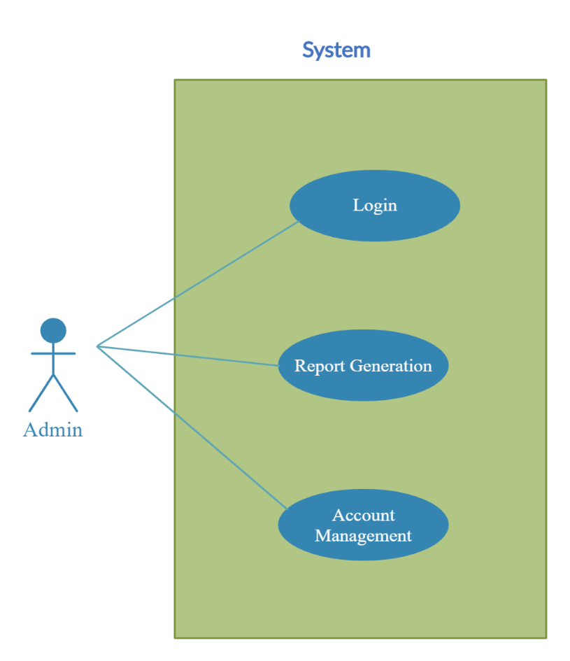

*Fig. Use case diagram for Admin*

1. In Admin use case diagram Admin is the Actor.
2. Admin can handle following use cases:
3. Login
4. Report Generation
5. Controls account

**Student and Parent**

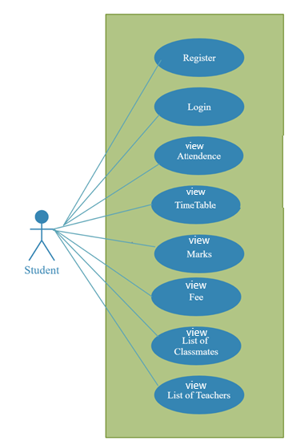

*Fig. Use case diagram for student and parent*

1. In Student use case diagram Student is the Actor.
2. Student can handle following use cases:
3. Register
4. Login
5. View Attendance
6. View Timetable
7. View Marks
8. View Product
9. View Student and teacher list

**Teacher**

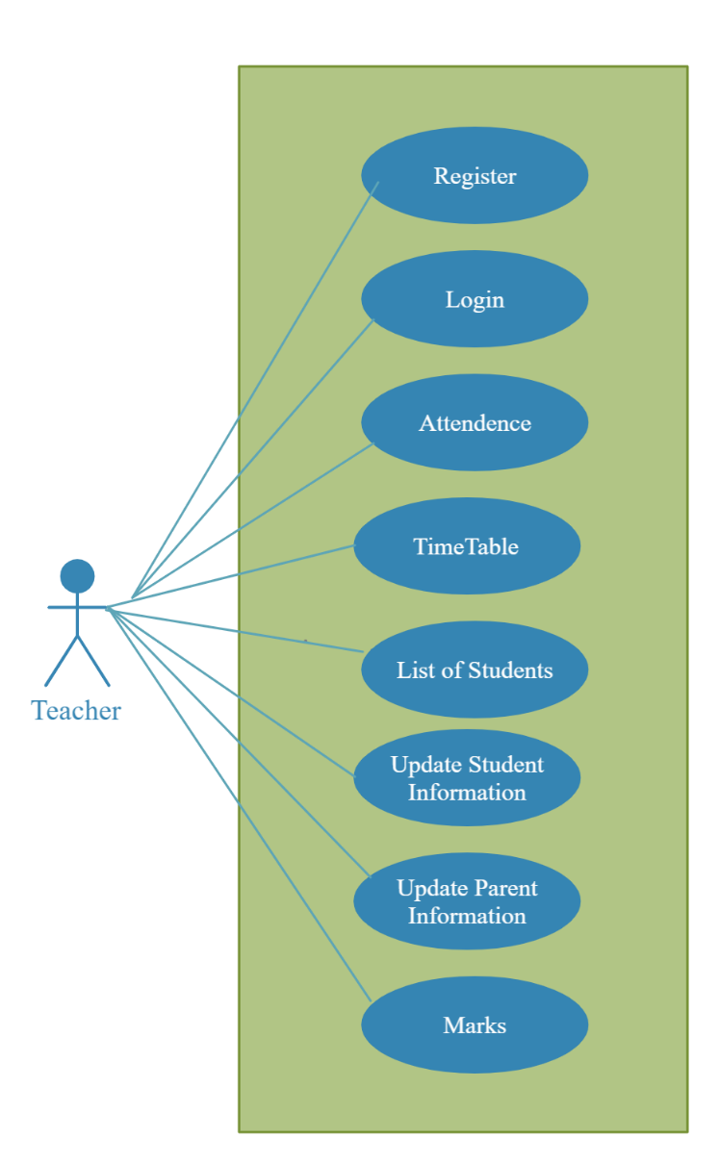

*Fig. Use case diagram for Teacher*

1. In Teacher use case diagram Teacher is the Actor**.**
2. Teacher can handle following use cases:
3. Register
4. Login
5. Manage Attendance
6. View Timetable
7. View Student List
8. Update Student Information
9. Update Marks

**Clerk**

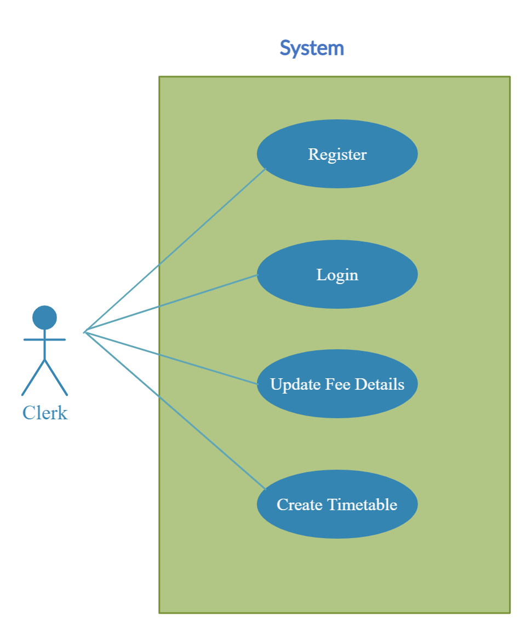

*Fig. Use case diagram for clerk*

1. In Clerk use case diagram Clerk is the Actor**.**

2. Clerk can handle following use cases:

a. Register

b. Login

c. Update fee details

d. Create Timetable